ServiceNow to ServiceNow Integration Setup Guide

Overview
This document provides the step-by-step procedure to configure a ServiceNow to ServiceNow integration. The setup involves configuring the Target Instance to allow inbound integration access and configuring the Source Instance to connect and submit requests to the Target Instance.

Part 1: Configure Target Instance
Target: https://dthitdemo01.service-now.com/

Step 1: Create Integration User
The integration user will be used by the Source Instance to authenticate and communicate with the Target Instance.

Navigation
- Log in to the Target ServiceNow Instance
- Navigate to: User Administration > Users
- Click New

Configure User Details
Make sure that the Identity type is in the form layout:

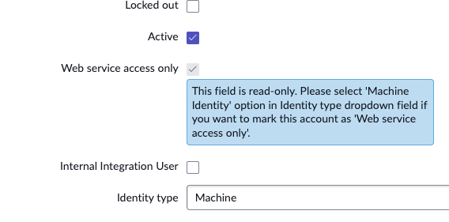
Populate the required user information and set the Identity type as “Machine” – see the screenshot above.

Save User Record
After saving:
- Take note of the following information:
  - User ID
  - Password (Using Set Password)
These credentials will be used when creating the connection from the Source Instance.
Assign the following roles:
- rest_service
- web_service_admin

Step 2: Commit the update set: [TARGET] - SN 2 SN Catalog Item Integration

Step 3: Update the basic auth credential password
Navigate to this link: https://<<instance_name>>.service-now.com/basic_auth_credentials.do?sys_id=71ae271f871dc7507c8187f4dabb353d

Password: {xfya+vEm!Ma-9T5%t5xV.O!E#^{HQ{ld_Xzq;oA-}b[P03n-ohx)L2Idv$y-tD#7VJ6zb7nb9hkzOH%hqdOv>$y[mvrUGZG850W

Part 2: Configure Source Instance
Source: https://thehubdev1.service-now.com/

Step 2: Create Credential Alias
The Credential Alias stores the authentication details required to connect from the Source Instance to the Target Instance.

Navigation
Navigate to: Integration Hub > Connections & Credentials > Connection & Credential Aliases then click New

Configure Credential Alias
Populate the following fields:
Field | Value
Name | Any preferred name
Type | Credential
Click Save.

Create Basic Authentication Credential
Under the Credential related list:
- Click New
- Select: Basic Auth Credentials
- Populate the following fields:
Field | Value
Name | Any preferred name
User name | User ID created in Target Instance
Password | Password created in Target Instance
Click Save.

Step 3: Create SN to SN Customer Record
The SN to SN Customer record contains the connection configuration information used to communicate with the Target Instance.

Navigation
Navigate to: SN to SN > Customers > New

Populate Customer Details
Enter the following information:
Field | Value
Brand | Customer name of the Source Instance
Instance URL | Target API endpoint
Client Credentials | Credential Alias created in Step 2

Instance URL Format
Use the following format:
https://<target-instance>.service-now.com/api/dthit/sn2sn_catalog/submit

Example:
https://dthitdemo01.service-now.com/api/dthit/sn2sn_catalog/submit

Save Record
Click: Save

Step 4: Create Catalog Configuration
The Catalog Config record maps the Source Instance catalog item to the Target Instance catalog item.

Navigation
Navigate to: SN to SN > Catalog Configs > New

Populate Catalog Configuration
Enter the following details:
Field | Value
Brand | SN to SN Customer record created in Step 3
Catalog Item Name | Name of catalog item from Target Instance
Catalog Item SysID | Sys ID of catalog item from Target Instance
Source Catalog Item | Catalog item from Source Instance

Save Record
Click: Save

Step 5: Validate the catalog mappings
The Catalog item from the target instance must be identical to the source instance. Customer field that is referenced to SN to SN > Customer must be available from the source's catalog item.

Source Catalog item
Validate the following details
Field | Value
Flow | SN to SN Flow
Variables | Customer (reference to u_sn2sn_customer)
Other Variables | Same variables to target instance

Sample Catalog Item [SOURCE]
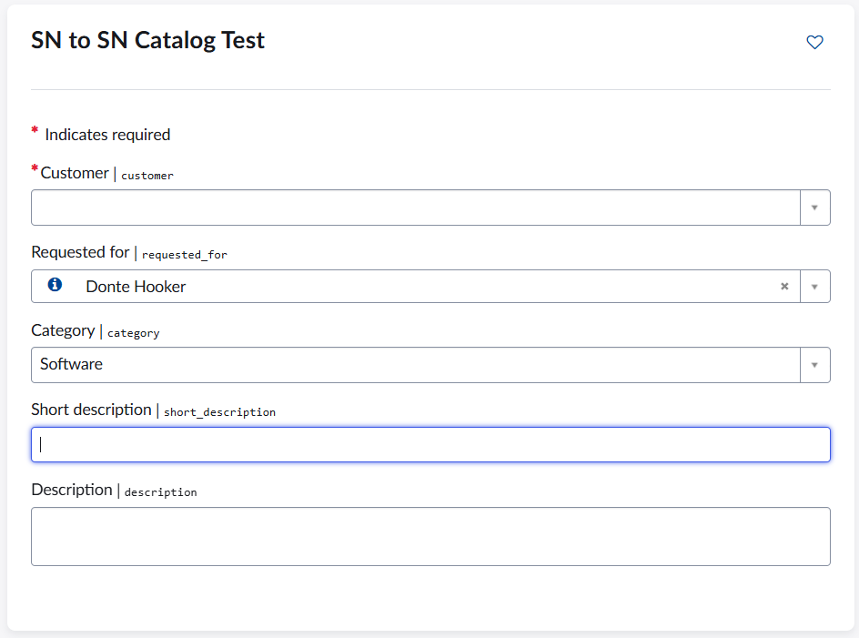

Sample Catalog Item [TARGET]
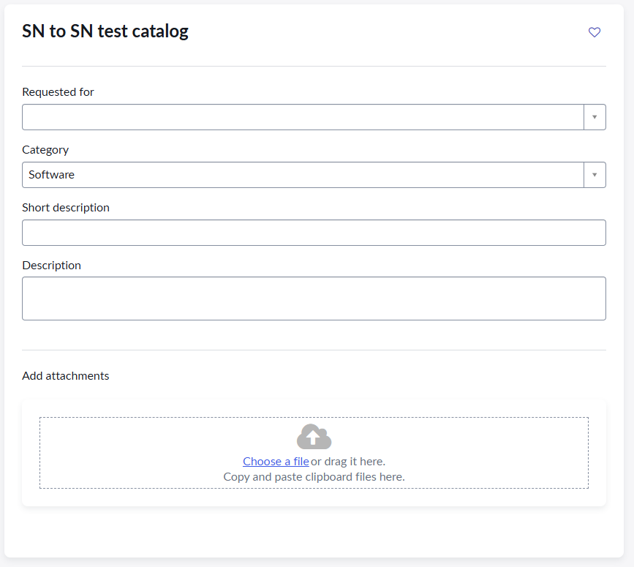

Validation Checklist
Before testing the integration, confirm the following:

Target Instance
☐ Integration user exists
☐ Web service access only is enabled
☐ Required roles are assigned
☐ User ID and password are available

Source Instance
☐ Credential Alias created
☐ Basic Authentication credential configured
☐ SN to SN Customer record created
☐ Target API endpoint is correct
☐ Catalog Config mapping is completed

